Software Test Library User Guide – Platform Fault Injection Based Learning Framework
Document# 0402
Author: | Panjam Veerabhaskar
Version: | 1.0
Date: | 19-02-2026
Status: | Released

1 Revision History
Version | Date | Description | Author
0.1 | 09 -01-2026 | Initial Draft | Panjam Veerabhaskar
0.2 | 05-02-2026 | Added the ESP32 OTA Update Using GitHub Pages chapter | Panjam Veerabhaskar
0.3 | 19-02-2026 | Addressed the review comments | Panjam Veerabhaskar
1.0 | 19-02-2026 | Released | Panjam Veerabhaskar

2 Review
File Name | Software Test Library User Guide - platform fault injection based learning framework
Document
Revision | 1.0
Reviewer | Saisree K, Vishwanath P

3 Release
Document release version: | V 1.0

 | Name | Organization,  Division,  Function | Date | Signature
Prepared | Panjam Veerabhaskar | AiSemi Pvt.Ltd, Embedded Systems | 09-01-2026 | Panjam Veerabhaskar
Reviewed | Saisree K | AiSemi Pvt.Ltd | 16-02-2026 | Saisree K
Released | Panjam Veerabhaskar | AiSemi Pvt.Ltd,  Embedded Systems | 19-02-2026 | Panjam Veerabhaskar

Table of Contents
1 Revision History 2
2 Review 2
3 Release 2
4 Purpose 6
5 Scope 6
5.1 In Scope 6
5.2 Out Scope 7
6 Standards and References 8
6.1 Standards 8
6.2 Reference 8
7 Abbreviations 9
8 Definitions 9
9 Introduction 10
10 Connectivity Diagram and Hardware Setup 11
10.1 System Connectivity Overview 12
10.2 ESP32-to-ESP32 I2C Connectivity 12
10.3 ESP32-to-Sensor Connectivity 12
10.4 Fault Injection Switch Connectivity 12
10.5 External Fault Stimulation Connections 13
10.6 Connectivity Verification and Troubleshooting 13
11 Functional Specifications 13
11.1 Objective 14
11.2 Functional Overview 14
11.2.1 System Initialization 14
11.2.2 Sensor Data Acquisition 15
11.2.3 Diagnostic Monitoring 15
11.2.4 Fault Injection Control 15
11.2.5 Diagnostic Reporting 15
11.2.6 Recovery and Normalization 15
12 Sensor-wise Functional Behavior 15
12.1 Temperature Sensor – MCP9808 16
12.1.1 Functional Description 16
12.1.2 Normal Operating Behavior 16
12.1.3 Diagnostic Monitoring 16
12.1.4 Fault Injection Interaction 16
12.1.5 Learning Objectives 17
12.2 Ambient Light Sensor – TSL2591 17
12.2.1 Functional Description 17
12.2.2 Normal Operating Behavior 17
12.2.3 Diagnostic Monitoring 17
12.2.4 Fault Injection Interaction 17
12.2.5 Learning Objectives 18
12.3 Color Sensor – TCS34725 (with WS2812 LED) 18
12.3.1 Functional Description 18
12.3.2 Normal Operating Behavior 18
12.3.3 Diagnostic Monitoring 18
12.3.4 Fault Injection Interaction 19
12.3.5 Learning Objectives 19
12.4 Rotary Encoder – Stepper Driven (ULN2003A) 19
12.4.1 Functional Description 19
12.4.2 Normal Operating Behavior 19
12.4.3 Diagnostic Monitoring 19
12.4.4 Fault Injection Interaction 20
12.4.5 Learning Objectives 20
13. System Programming and Result Monitoring Procedure 20
13.1 Firmware Upload to ESP32 Boards 20
13.1.1 Upload Initiator ESP32 Firmware 20
13.1.2 Upload Target ESP32 Firmware 22
13.2 Method 1 – Viewing Results Using Serial Monitor 23
13.2.1 Connect Initiator ESP32 23
13.2.2 Open Serial Monitor 23
13.2.3 Configure Baud Rate 23
13.2.4 Expected Output in Serial Monitor 24
13.3 Method 2 – Viewing Results Using Web Interface 24
13.3.1 Obtain IP Address 24
13.3.2 Access Web Dashboard 25
13.3.3 Start System Operation 25
13.3.4 Expected Output on Web Interface 26
14 ESP32 OTA Update Using GitHub Pages 26
14.1 Functional Description of the Chapter 27
14.2 System Requirements and Constraints 27
14.3 Step-by-Step Online Firmware Deployment Procedure 27
14.4 Initial Firmware Installation Requirement 33
14.5 Online Firmware Resources 33
14.6 Firmware Update Execution Flow 33

4 Purpose
The purpose of this document is to define and describe the Software Test Library (STL) and its intended use for learning and developing diagnostic software using a platform-level fault-injection approach.
This user guide provides structured guidance on how the STL can be used with a multi-node hardware platform, where controlled faults and abnormal operating conditions are intentionally introduced to:
- Demonstrate how diagnostic software detects faults at the system and communication levels.
- Illustrate the difference between fault injection–based detection and out-of-range / plausibility checks.
- Enable learners to observe software behavior under abnormal conditions in a controlled and repeatable manner.
The document is primarily intended to support software developers and learners who are gaining hands-on experience in:
- Embedded software development.
- Diagnostic function implementation.
- Robust software design practices.
This guide focuses on the usage of the STL APIs, the interaction between software and hardware during fault scenarios, and the expected diagnostic responses, rather than on detailed hardware or sensor internal design.
The ultimate objective of this document is to enable users to:
- Understand how faults manifest at software interfaces.
- Design and validate diagnostic checks.
- Gain practical exposure to real-world fault scenarios using physical hardware stimulation.

5 Scope

5.1 In Scope
The following items are within the scope of this document:
- Description of the Software Test Library (STL) and its intended usage for learning and development
- Overview of the platform-level fault injection concept implemented using an ESP32-based hardware setup
- Interaction between Initiator and multiple Target ESP32 nodes using I2C communication
- Usage of I2C-based fault injection mechanisms via a bilateral switch
- Connectivity diagrams and wiring information, including:
  - ESP32-to-ESP32 I2C connections
  - ESP32-to-sensor connections
  - Switch(M74HC4066) placement on the I2C signal line
  - Power and ground connections
Note - These diagrams are provided to enable users to verify and restore correct connections in case of loose or incorrect wiring.
- Software call flow and API usage for:
  - Sensor initialization
  - Data acquisition
  - Diagnostic checks
  - Fault injection control
- Diagnostic software behavior related to:
  - Communication faults
  - Sensor malfunction scenarios
  - Out-of-range and plausibility violations
- Hands-on learning exercises for each sensor, including:
  - Fault injection detection exercises
  - Out-of-range detection exercises using physical stimulus (e.g., temperature rise, light variation, speed change)
- Observation and interpretation of diagnostic outcomes such as error flags, logs, and status indications

5.2 Out Scope
The following items are explicitly out of scope for this document:
- Detailed hardware design schematics or PCB layout files
- Internal silicon architecture of ESP32 devices
- Internal functional design of individual sensors
- Electrical characteristics, timing closure, or signal integrity analysis
- Production-quality safety certification or compliance claims (e.g., ISO 26262, IEC 61508)
- Formal safety analyses such as FMEDA, FMEA, or fault tree analysis
- RTL, firmware bootloader, or low-level driver implementation details
- Performance benchmarking or stress testing beyond educational and learning objectives

6 Standards and References

6.1 Standards
Ref. | Title | Author | Date
#N1

6.2 Reference
Ref. | Title | Version | Author | Date
#R1 | MCP9808 High-Accuracy Temperature Sensor Datasheet | Latest | Microchip | Latest
#R2 | TSL2591 High Dynamic Range Ambient Light Sensor Datasheet | Latest | ams OSRAM | Latest
#R3 | TCS34725 Color Light-to-Digital Converter Datasheet | Latest | ams OSRAM | Latest
#R4 | Adafruit I2C QT Rotary Encoder (4991) Datasheet | Latest | Adafruit | Latest
#R5 | M74HC4066 Quad Bilateral Switch Datasheet | Latest | STMicroelectronics / NXP | Latest
#R6 | ESP32 Hardware Design Guidelines | Latest | Espressif Systems | Latest
#R7 | WS2812 RGB LED Breakout Module | Latest | WORLDSEMI CO., LIMITED | Latest
#R8 | ULN2003A Driver Module Stepper Motor Driver | Latest | STMICROELECTRONICS [STMicroelectronics] | Latest

7 Abbreviations
Abbreviation | Meaning
STL | Software Test Library
ESP32 | Espressif 32-bit Microcontroller
I2C | Inter-Integrated Circuit

8 Definitions
Definition | Meaning | Entails
Fault | An abnormal physical or logical condition introduced intentionally or occurring naturally within the system | May affect communication, sensor behavior, or signal integrity
Fault Injection | A controlled technique used to introduce faults into a system intentionally | Used to validate diagnostic software behavior
Error | An incorrect internal system state resulting from one or more faults | May be detected or remain latent
Diagnostic | A software mechanism that monitors system behavior to detect faults or errors | Includes checks, monitoring, and reporting
Out-of-Range Condition | A condition where a valid signal exceeds predefined acceptable limits | Indicates abnormal operation, but not necessarily a fault
Plausibility Check | A diagnostic check that validates whether the measured data is reasonable based on expected behavior | Detects sudden, inconsistent, or unrealistic changes
Initiator | The ESP32 node that initiates I2C communication and coordinates system operation | Requests data and controls diagnostics
Target | An ESP32 node that responds to I2C communication requests and interfaces with sensors | Provides sensor data and status
Sensor | A hardware component that measures a physical quantity and provides digital data | Temperature, light, color, or rotation
I2C Bus | A serial communication interface used for data exchange between the initiator and target nodes | Includes SDA and SCL signal lines
Switch | A hardware device used to selectively connect or disconnect signal paths | Enables controlled fault injection
Platform Fault Injection | Fault injection is performed at the system or communication level rather than inside the software | Simulates real-world hardware faults
Diagnostic Coverage | The ability of diagnostic software to detect faults within a defined time | Evaluated through exercises
Recovery | System behavior after detection of a fault or error | May include retry, reset, or safe handling

9 Introduction
This document describes the Software Test Library (STL) and its usage within a platform fault injection–based learning framework. The STL is designed to support the development and validation of diagnostic software by providing a structured set of software interfaces, test hooks, and exercises that operate on a real hardware platform.

The learning platform is based on an ESP32 multi-node architecture, consisting of one Initiator ESP32 and multiple Target ESP32 nodes connected via an I2C communication bus. Each Target ESP32 interface with a specific sensor, enabling measurement of different physical quantities such as temperature, ambient light, color, and rotational movement.

To enable practical learning of diagnostic concepts, the platform incorporates controlled fault injection at the hardware interface level. Faults are introduced using a bilateral switch placed on the I2C signal path between the ESP32 and the sensor. This approach allows faults to be injected without modifying the application software, thereby closely resembling real-world fault scenarios.

In addition to fault injection, the platform supports out-of-range and plausibility-based diagnostic scenarios through external physical stimulation, such as:
- Sudden temperature changes
- Rapid light intensity variation
- Abnormal color input
- Unusual rotational speed or direction changes
These scenarios enable learners to understand how diagnostic software distinguishes between communication faults, sensor malfunctions, and valid but abnormal operating conditions.

This user guide provides step-by-step guidance on:
- System setup and connectivity
- Software architecture and API usage
- Diagnostic behavior and expected outcomes
- Sensor-specific learning exercises

The focus of this document is on software usage and behavior, enabling learners to gain hands-on experience in designing, executing, and validating diagnostic software using a realistic and repeatable hardware-based environment.

10 Connectivity Diagram and Hardware Setup
This chapter describes the hardware connectivity and wiring arrangement of the platform used with the Software Test Library (STL). This chapter intends to enable users to correctly connect, verify, and restore hardware connections, especially in scenarios where loose or incorrect wiring may impact software behavior.
The connectivity information provided in this chapter is essential for:
- Successful execution of diagnostic software
- Correct fault injection behavior
- Troubleshooting communication-related issues
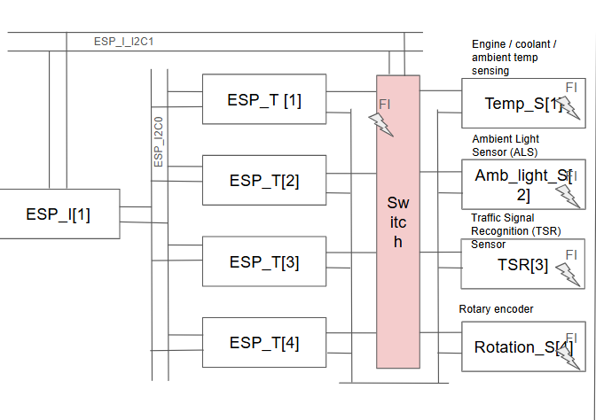

10.1 System Connectivity Overview
The platform consists of:
- One Initiator ESP32, responsible for coordinating system operation and executing diagnostic software.
- Four Target ESP32 nodes, each interfacing with a dedicated sensor.
- An I2C communication bus connecting the Initiator and all Target nodes.
- A bilateral switch is placed on the I2C signal line between each Target ESP32 and its associated sensor to enable fault injection.
All ESP32 nodes share a common power supply and ground reference.

10.2 ESP32-to-ESP32 I2C Connectivity
- The Initiator ESP32 acts as the I2C initiator on the bus.
- Each Target ESP32 is configured with a unique I2C address
- The following signals are connected between the Initiator and all Target nodes:
  - I2C Serial Data Line (SDA)
  - I2C Serial Clock Line (SCL)
  - Ground (GND)
Pull-up resistors are used on the I2C bus as per standard I2C design guidelines(as applicable).

10.3 ESP32-to-Sensor Connectivity
Each Target ESP32 interfaces with one sensor using I2C communication. The connections include:
- SDA lines routed through the fault injection Switch
- SCL line is directly connected to the Target ESP32
- Power supply (VCC)
- Ground (GND)
The sensor mapping is as follows:
- Target ESP32 [1] – Temperature Sensor (MCP9808)
- Target ESP32 [2] – Ambient Light Sensor (TSL2591)
- Target ESP32 [3] – RGB Color Sensor (TCS34725)
- Target ESP32 [4] – Rotary Encoder (Adafruit QT Encoder 4991)

10.4 Fault Injection Switch Connectivity
A bilateral switch (M74HC4066) is placed on the I2C SDA signal path between each Target ESP32 and its associated sensor.
The switch allows:
- Normal operation mode, where the sensor is directly connected
- Fault injection mode, where the signal path is altered or interrupted
The switch control signal is driven by the Initiator ESP32 and controlled via software APIs provided by the STL.

10.5 External Fault Stimulation Connections
To support out-of-range and plausibility-based diagnostic exercises, additional external components are connected to the platform, including:
- Stepper motor for rotational speed and direction variation
- RGB LED (WS2812) for dynamic color and intensity changes
- External heat source (bulb) for temperature variation
- External light source (bulb) for ambient luminance variation.
These components are used only to stimulate physical conditions and do not directly interface with the diagnostic software.

10.6 Connectivity Verification and Troubleshooting
Connectivity diagrams are provided to assist users in:
- Verifying correct wiring before software execution.
- Identifying and correcting loose or disconnected wires.
- Restoring correct connections after fault injection experiments.
Users are recommended to verify:
- Power and ground continuity.
- Correct I2C signal routing.
- Correct placement of the switch on the signal line.
- Unique I2C addresses for each Target ESP32.

11 Functional Specifications
This chapter describes the functional capabilities and expected behavior of the Software Test Library (STL) when used with the platform fault injection setup. The functional specifications define what the STL provides, how it is intended to be used, and what outcomes are expected during normal and fault-injected operation.
The STL is designed to operate as a learning-oriented diagnostic framework, enabling users to interact with real hardware, introduce controlled fault conditions, and observe software responses in a structured and repeatable manner.

11.1 Objective
The primary objectives of the Software Test Library are to:
- Provide a standardized set of software interfaces (APIs) for sensor initialization, data acquisition, and diagnostics
- Enable platform-level fault injection without requiring changes to application software
- Support implementation and validation of diagnostic checks, including:
  - Communication fault detection
  - Sensor malfunction detection
  - Out-of-range detection
  - Plausibility and consistency checks
- Allow learners to observe, analyze, and interpret diagnostic behavior under both normal and abnormal operating conditions.
- Facilitate hands-on exercises that reinforce core embedded software concepts such as robustness, monitoring, and error handling.
The STL is intended as a learning and experimentation framework and does not claim production-level diagnostic completeness or safety certification compliance.

11.2 Functional Overview
The Software Test Library (STL) provides a structured set of software functions that enable sensor interaction, diagnostic monitoring, and fault injection control on a multi-node ESP32 platform.
At a functional level, the STL operates by coordinating interactions between the Initiator ESP32 and multiple Target ESP32 nodes, each of which interfaces with a dedicated sensor. The STL abstracts hardware-specific details and exposes well-defined APIs that allow users to focus on software behavior and diagnostic logic rather than low-level implementation.
The key functional elements of the STL include:

11.2.1 System Initialization
- Initialization of the Initiator and Target ESP32 nodes
- Configuration of I2C communication parameters
- Registration and configuration of connected sensors
- Initialization of fault injection control interfaces

11.2.2 Sensor Data Acquisition
- Periodic or on-demand acquisition of sensor data from Target nodes
- Support for multiple sensor types, including temperature, ambient light, color, and rotary input
- Validation of received data for format and availability

11.2.3 Diagnostic Monitoring
- Continuous monitoring of communication health between Initiator and Target nodes
- Execution of diagnostic checks, including:
  - Communication timeout detection
  - Invalid or missing data detection
  - Out-of-range value detection
  - Plausibility and consistency checks over time

11.2.4 Fault Injection Control
- Software-controlled activation and deactivation of platform-level fault injection
- Control of the I2C signal path via the switch
- Ability to introduce transient or persistent fault conditions

11.2.5 Diagnostic Reporting
- Generation of diagnostic status information
- Reporting of detected faults and abnormal conditions
- Support for observation through logs, indicators, or debug interfaces

11.2.6 Recovery and Normalization
- Detection-driven recovery actions, such as retry or reinitialization
- Restoration of normal operation after fault removal
- Verification of the sensor and communication recovery

12 Sensor-wise Functional Behavior
This chapter describes the functional behavior of each sensor integrated into the Software Test Library (STL) platform. For each sensor, the normal operating behavior, diagnostic monitoring, fault injection interaction, and learning objectives are described.
This chapter intends to enable users to:
- Understand expected sensor behavior during normal operation
- Observe the diagnostic software response during fault injection
- Learn how out-of-range and plausibility conditions are detected
Each sensor section follows a consistent structure to ensure clarity and ease of use.

12.1 Temperature Sensor – MCP9808

12.1.1 Functional Description
The MCP9808 is a high-accuracy digital temperature sensor connected to a Target ESP32 via the I2C interface. The sensor provides ambient temperature measurements at a configurable resolution.
During normal operation, the Target ESP32 periodically reads temperature data and forwards the measurements to the Initiator ESP32 through the I2C bus.

12.1.2 Normal Operating Behavior
- Temperature readings change gradually under stable environmental conditions.
- Data updates occur at a predefined sampling interval
- Communication between Initiator and Target remains continuous and error-free

12.1.3 Diagnostic Monitoring
The STL performs the following diagnostic checks for the temperature sensor:
- I2C communication availability and timeout detection
- Validity of received temperature data
- Out-of-range detection based on predefined temperature limits
- Plausibility checks to detect sudden or unrealistic temperature changes

12.1.4 Fault Injection Interaction
Platform-level fault injection is performed by altering the I2C signal path between the Target ESP32 and the MCP9808 using the switch.
Typical fault scenarios include:
- Temporary disconnection of the SDA line
- Intermittent communication disruption
- Persistent communication loss
The diagnostic software is expected to detect these conditions and report the fault accordingly.

12.1.5 Learning Objectives
By working with the temperature sensor, users learn to:
- Distinguish between communication faults and valid sensor data
- Implement and validate out-of-range detection
- Understand the impact of sudden environmental changes on diagnostics

12.2 Ambient Light Sensor – TSL2591

12.2.1 Functional Description
The TSL2591 is a high dynamic range ambient light sensor connected to a Target ESP32 via the I2C interface. The sensor measures ambient light intensity and provides digital output values representing illumination levels over a wide range of operating conditions.
During normal operation, the Target ESP32 periodically acquires ambient light data from the sensor and transmits the measured values to the Initiator ESP32 for diagnostic evaluation.

12.2.2 Normal Operating Behavior
- Ambient light readings vary smoothly with changes in environmental lighting.
- Data updates are provided at a configured sampling rate
- Communication between the Initiator and Target ESP32 remains stable and continuous

12.2.3 Diagnostic Monitoring
The STL performs the following diagnostic checks for the ambient light sensor:
- Detection of I2C communication timeouts and errors
- Validation of received light intensity data
- Out-of-range detection based on predefined illumination thresholds
- Plausibility checks to detect abrupt or unrealistic changes in light intensity

12.2.4 Fault Injection Interaction
Fault injection for the TSL2591 is performed by manipulating the I2C signal path between the Target ESP32 and the sensor using the switch.
Representative fault scenarios include:
- Intermittent loss of communication due to signal interruption
- Persistent disconnection of the sensor from the I2C bus
- Corrupted or missing data transactions
The diagnostic software is expected to detect these fault conditions and report them in a timely manner.

12.2.5 Learning Objectives
Through exercises involving the ambient light sensor, users learn to:
- Detect communication-related faults using diagnostic software
- Differentiate between valid rapid light changes and fault-induced anomalies
- Implement plausibility checks for sensor data with high dynamic range

12.3 Color Sensor – TCS34725 (with WS2812 LED)

12.3.1 Functional Description
The TCS34725 is an RGB color sensor connected to the Target ESP32 through the I2C interface. A WS2812 RGB LED is used as the light source. The Target ESP32 drives the WS2812 LED to display specific colors, and the TCS34725 detects the reflected color values.
During normal operation, the Target ESP32 reads the RGB data from the sensor and sends it to the Initiator ESP32.

12.3.2 Normal Operating Behavior
- The WS2812 LED displays predefined colors
- The TCS34725 detects RGB values corresponding to the displayed LED color
- Color readings remain stable when the LED color is constant
- I2C communication between the Initiator and Target ESP32 is stable

12.3.3 Diagnostic Monitoring
The system monitors the following:
- I2C communication status with the color sensor
- Validity of RGB data from the TCS34725
- Consistency between LED color and detected sensor values

12.3.4 Fault Injection Interaction
Faults are injected by interrupting the I2C communication with the sensor. Example fault cases include:
- Sensor disconnected from the I2C bus
- Missing or invalid RGB data
The diagnostics are expected to detect and report these faults.

12.3.5 Learning Objectives
Through this exercise, users learn to:
- Read RGB color data using I2C
- Understand how a color sensor works with a controlled light source
- Detect basic sensor communication faults
- Identify mismatches between LED color and sensor readings

12.4 Rotary Encoder – Stepper Driven (ULN2003A)

12.4.1 Functional Description
The rotary encoder is rotated using a stepper motor driven by a ULN2003 motor driver. The ULN2003 is controlled by the Target ESP32 to rotate the motor, and the encoder provides position feedback through the I2C interface.
During normal operation, the Target ESP32 drives the motor and reads the encoder position, then sends the data to the Initiator ESP32.

12.4.2 Normal Operating Behavior
- Encoder position changes according to motor rotation
- Position increases or decreases based on the rotation direction
- Encoder value remains constant when the motor is stopped
- Communication between the Initiator and Target ESP32 is stable

12.4.3 Diagnostic Monitoring
The system monitors the following:
- Encoder I2C communication status
- Validity of encoder position values
- Consistency between motor movement and encoder feedback

12.4.4 Fault Injection Interaction
Fault injection for the Rotary Encoder is performed by manipulating the I2C signal path between the Target ESP32 and the sensor using the switch.
Example fault cases include:
- Encoder data is missing while the motor rotates
- Encoder disconnected from the I2C bus
- Motor not rotating due to ULN2003 signal loss
The diagnostics are expected to detect and report these faults.

12.4.5 Learning Objectives
Through this exercise, users learn to:
- Read encoder position using I2C
- Understand the relation between motor rotation and encoder output
- Detect basic communication faults
- Identify a mismatch between motor movement and encoder feedback

13. System Programming and Result Monitoring Procedure

13.1 Firmware Upload to ESP32 Boards
All firmware must be uploaded individually to each ESP32 board before system operation.

13.1.1 Upload Initiator ESP32 Firmware
- Connect the Initiator ESP32 to the computer using a USB cable.
  - Ensure the power LED on the board is ON.
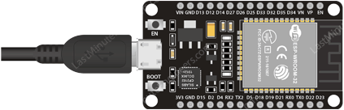
- Open Arduino IDE.
- Select the ESP32 board:
  - Go to Tools → Board
  - Select ESP32 Dev Module (or the specific ESP32 model used)
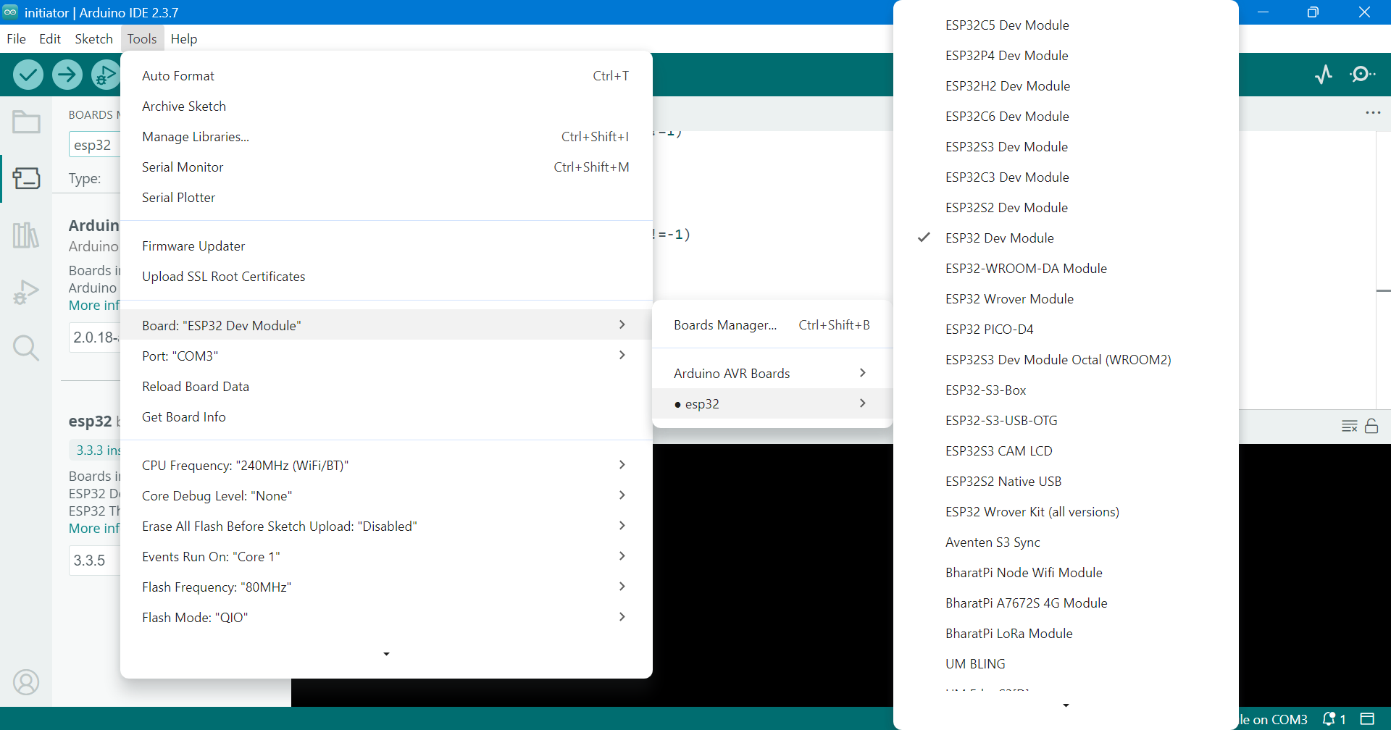
- Select the correct COM/USB port:
  - Go to Tools → Port
  - Select the appropriate port
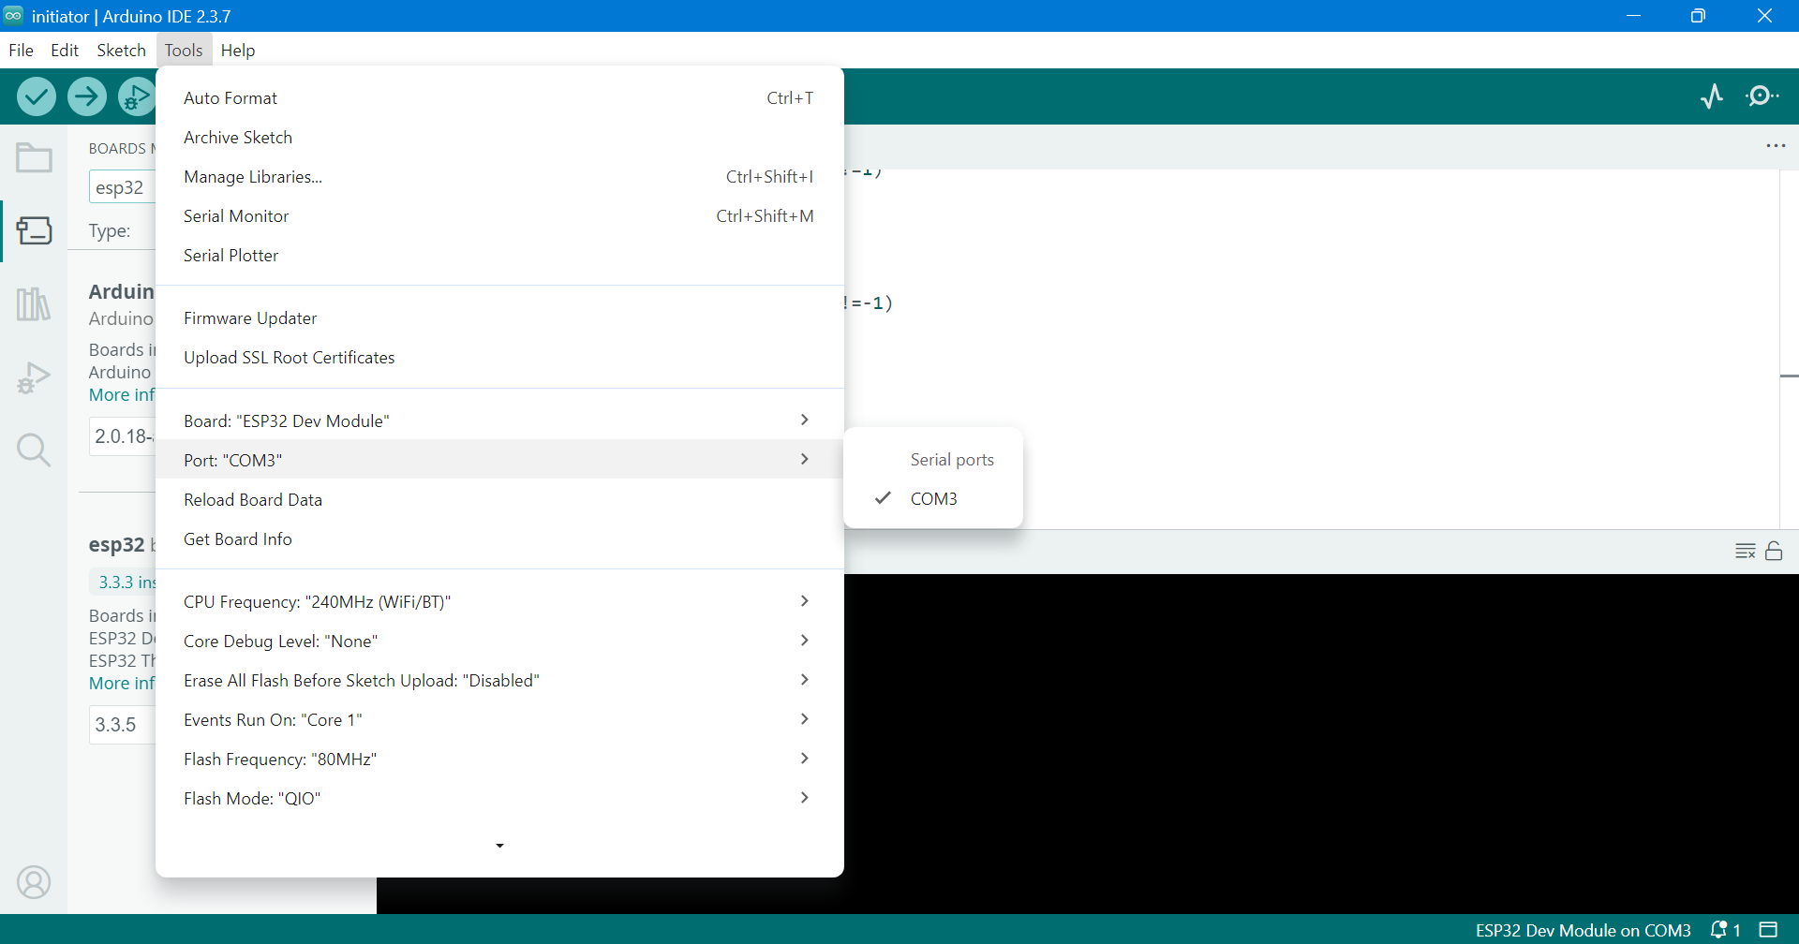
- Click Verify (✓) to compile the program.
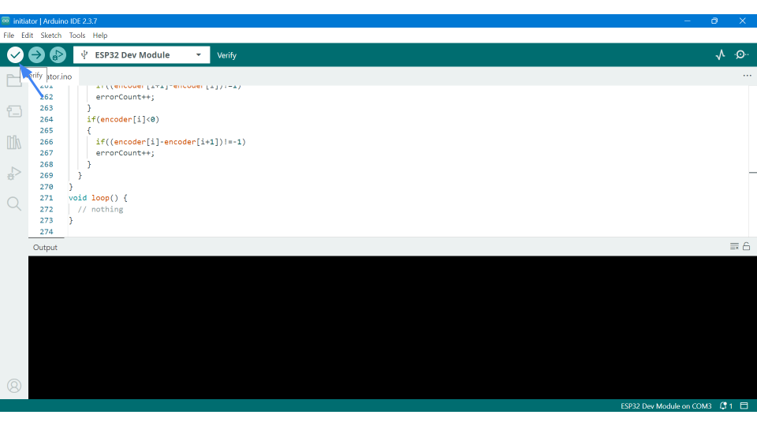
  - Resolve any compilation errors if present.
- Click Upload (→) to upload the firmware to the Initiator ESP32.
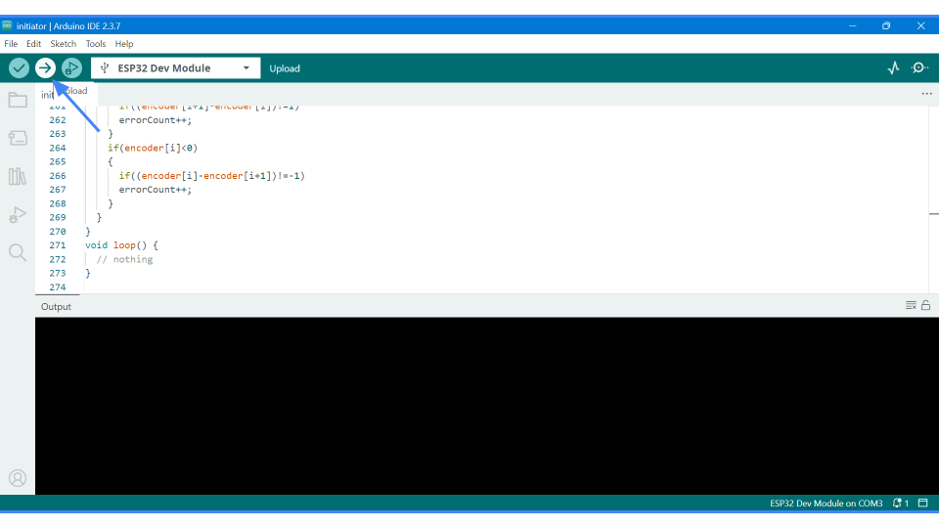

13.1.2 Upload Target ESP32 Firmware
Repeat the same procedure for:
- Target ESP32_1
- Target ESP32_2
- Target ESP32_3
- Target ESP32_4
Each Target ESP32 must be programmed separately with its respective firmware.
After completing all uploads:
- Power ON the Multi-node hardware platform board.
- Ensure all ESP32 boards are properly powered.

13.2 Method 1 – Viewing Results Using Serial Monitor
This method is intended for users who want to monitor results directly through the Arduino IDE.

13.2.1 Connect Initiator ESP32
- Disconnect all Target ESP32 boards from the computer.
- Connect only the Initiator ESP32 to the computer using a USB cable.

13.2.2 Open Serial Monitor
- Open Arduino IDE.
- Go to Tools → Serial Monitor.
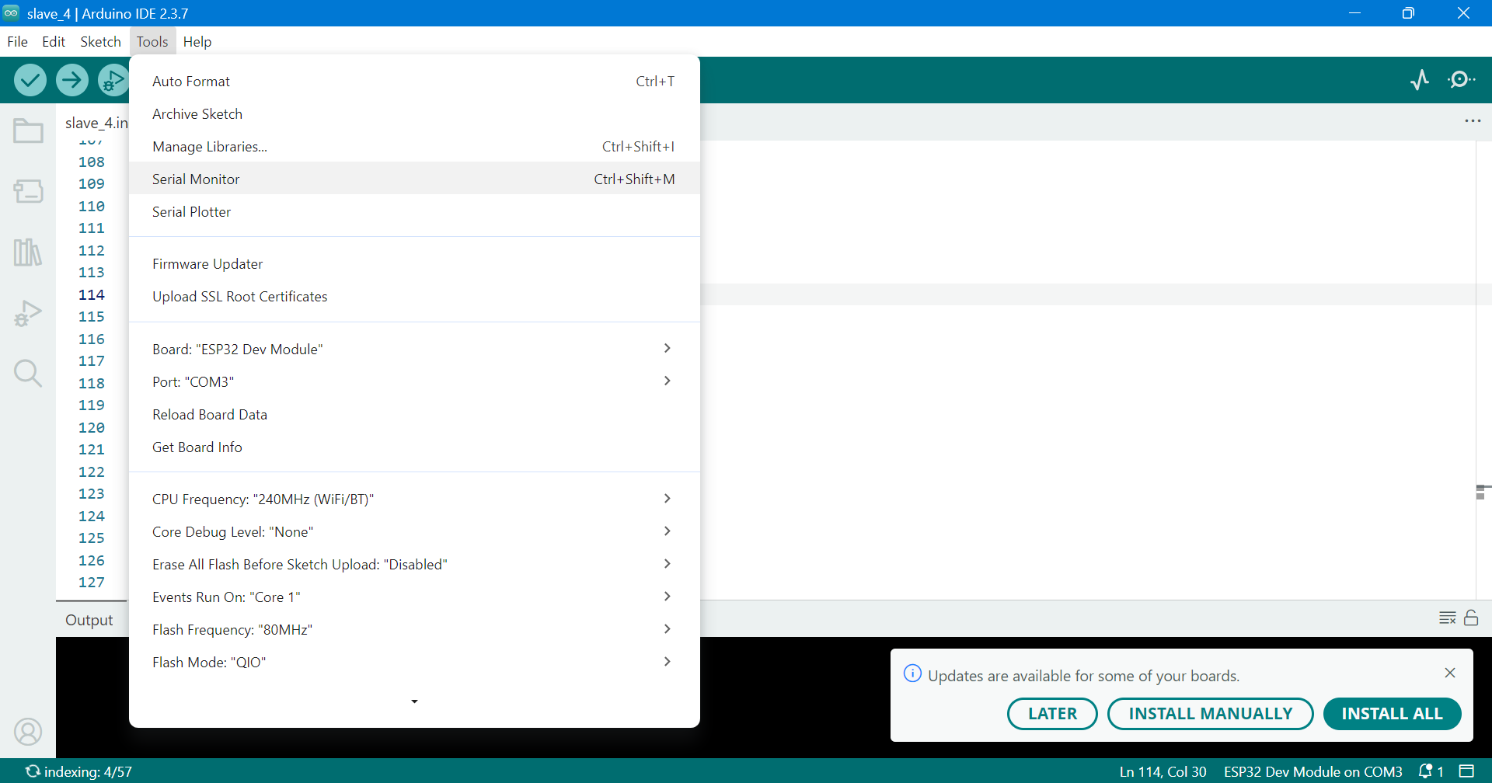

13.2.3 Configure Baud Rate
The Serial Monitor baud rate must match the baud rate defined in the firmware.
Example:
Serial.begin(115200);
Set the Serial Monitor baud rate to 115200.
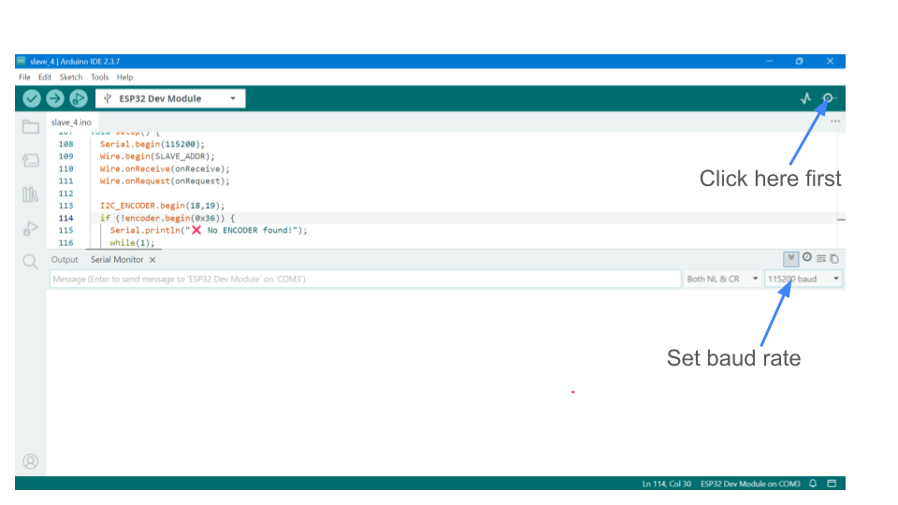

13.2.4 Expected Output in Serial Monitor
After Initiator READY, enter the START command in the input box, and the Serial Monitor will display:
- Sensor data samples received from all Target ESP32 boards
- Diagnostic error messages (if any fault is detected)
- Communication status logs
- System test result (PASS / FAIL)
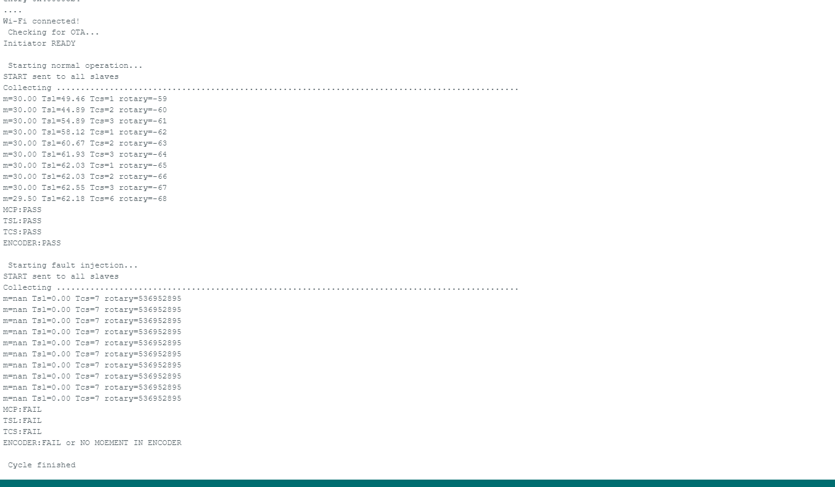

13.3 Method 2 – Viewing Results Using Web Interface
This method allows users to monitor system results through a web browser.

13.3.1 Obtain IP Address
- Power ON the Multi-node hardware platform board.
- Connect the Initiator ESP32 to the computer temporarily.
- Open Serial Monitor.
- After the Wi-Fi connection, note the IP address displayed.
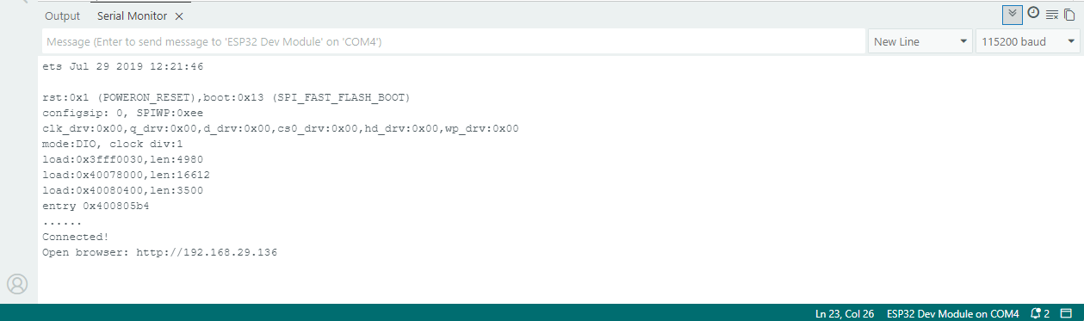
Example:
Connected
Open browser:http://192.168.29.136
- Disconnect the Initiator ESP32 boards from the computer.

13.3.2 Access Web Dashboard
- Copy the displayed IP address.
- Open a web browser (Chrome / Edge / Firefox).
Enter the IP address in the address bar:
http://192.168.29.136
- Press Enter.

13.3.3 Start System Operation
- The web page will display a Start button.
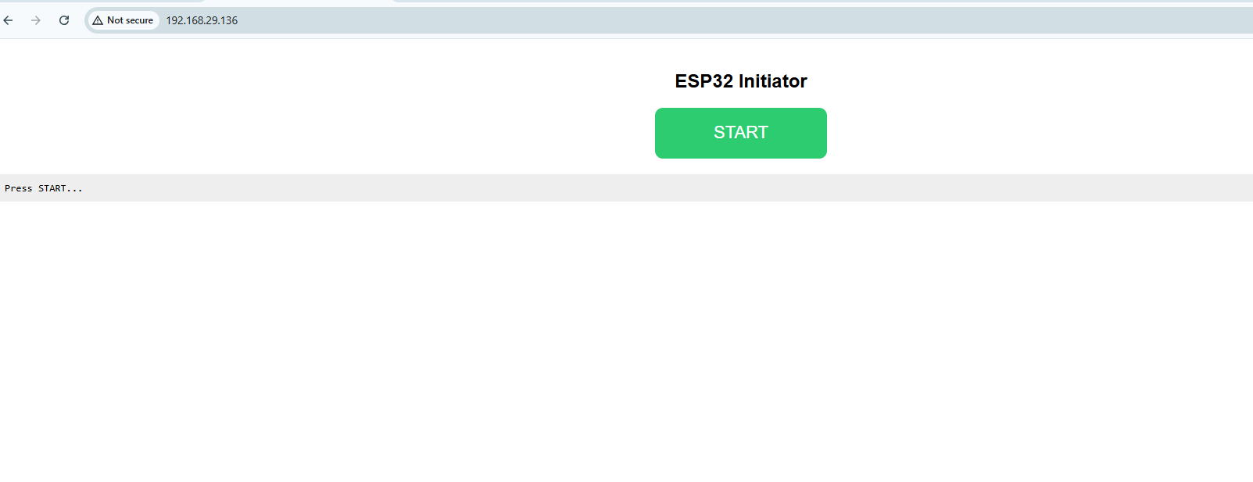
- Click the Start button.
- The system will begin communication with Target ESP32 boards.

13.3.4 Expected Output on Web Interface
After pressing Start, the web page will display:
- Sensor data from all Target ESP32 boards
- Error status information
- Fault detection messages (if any)
- Overall system test result (PASS / FAIL)
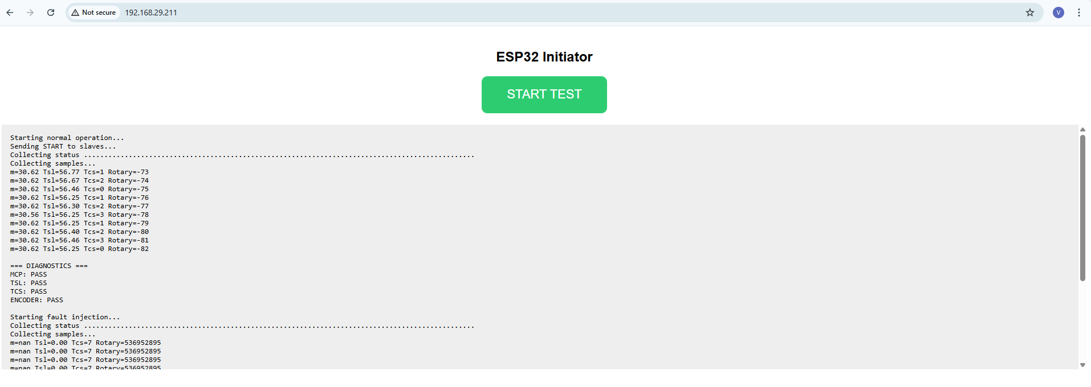
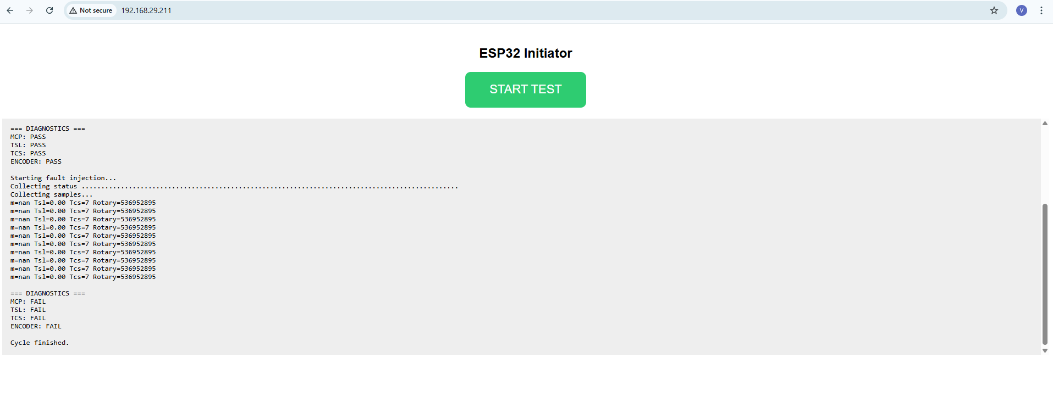

14 ESP32 OTA Update Using GitHub Pages
This chapter describes the implementation of an Over-The-Air (OTA) firmware update mechanism for the ESP32 microcontroller using GitHub Pages as the firmware hosting platform.
OTA updates allow firmware to be updated remotely over the internet without requiring a physical USB connection between the ESP32 device and a computer.
The objective of this chapter is to:
- Explain how ESP32 firmware can be hosted on an online platform
- Describe the use of GitHub Pages as a firmware hosting server
- Provide a structured, step-by-step procedure for online firmware deployment
- Enable ESP32 devices to safely check, download, and update firmware automatically

14.1 Functional Description of the Chapter
This chapter explains the complete OTA update process, including:
- Online access and repository creation
- Firmware and version file management
- Public web hosting of firmware files
- Secure access to firmware resources by the ESP32
- Remote firmware update execution
Once implemented, firmware updates require only the upload of a new .bin file and an updated version number. Physical access to the ESP32 hardware is not required after the initial setup.

14.2 System Requirements and Constraints
System Requirements
- ESP32 microcontroller with Wi-Fi capability
- Stable internet connectivity
- Arduino IDE for firmware compilation
- GitHub account for firmware hosting
Operational Constraints
- OTA updates cannot be performed on an unprogrammed ESP32
- Initial firmware must be installed using a USB interface

14.3 Step-by-Step Online Firmware Deployment Procedure
Step 1: GitHub Account Access
1. Open a web browser
2. Navigate to https://github.com
3. Log in to an existing account or create a new account
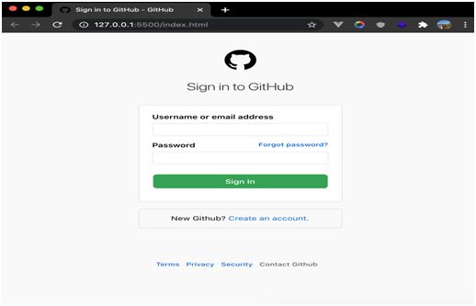
This account is used to host firmware files online.
Step 2: Repository Creation
1. Create a new public repository
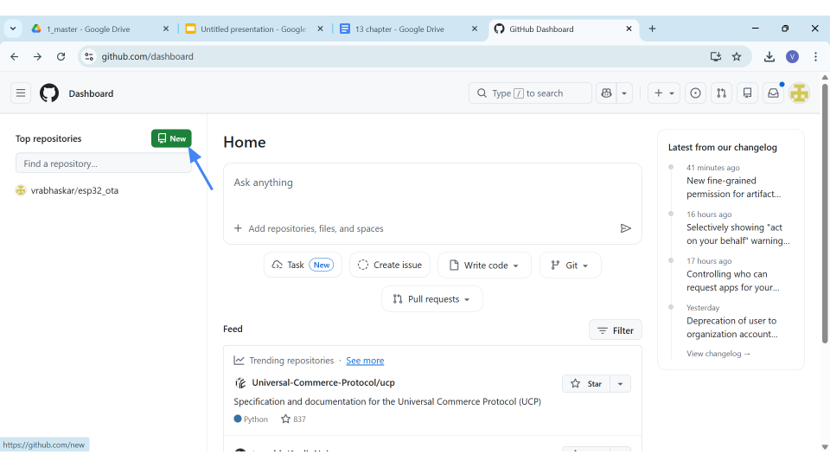
2. Repository name: e.g.,esp32_ota
3. Public visibility is mandatory for web access

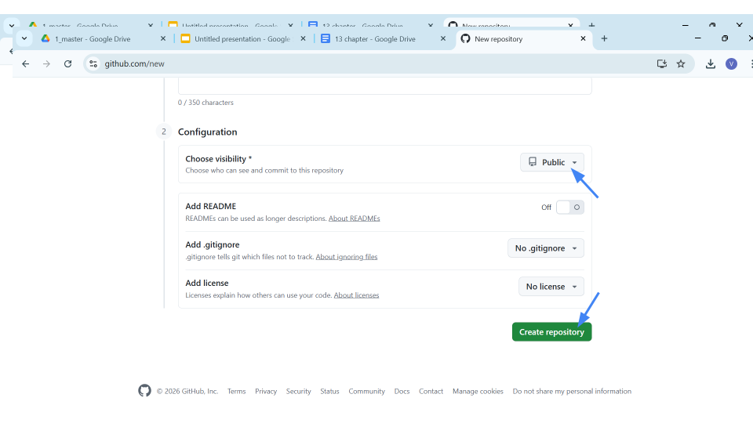

Step 3: Firmware Version File Creation
1. Create a file named:version.txt
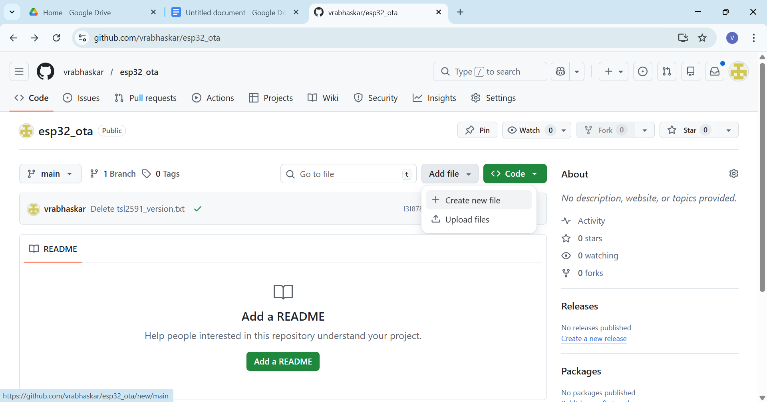
2. Enter the firmware version number:1.0.1(change version number every time new firmware uploaded)
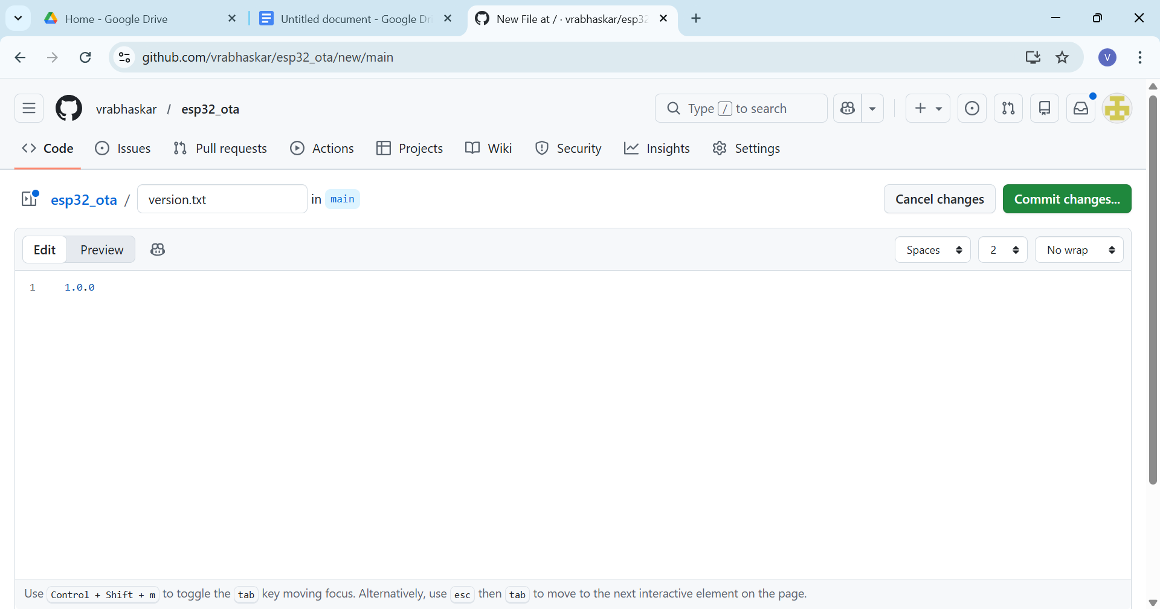
3. Commit the file to the repository
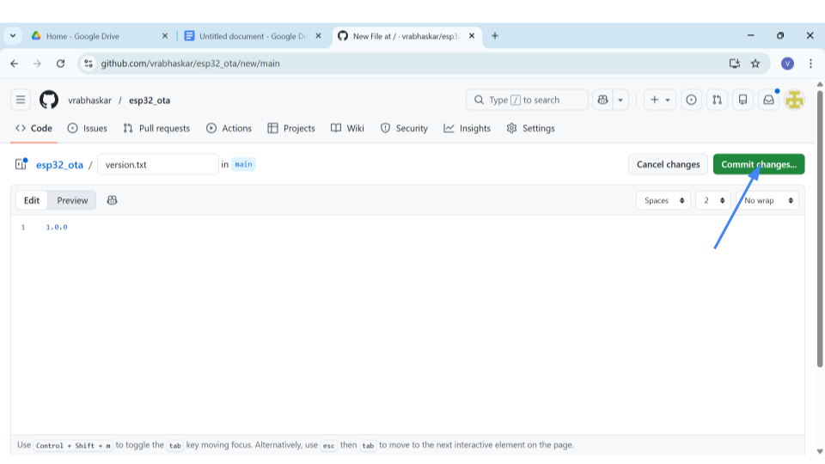
This file enables controlled firmware version checking.
Step 4: Firmware Compilation
1. Open the ESP32 firmware project in Arduino IDE
2. Select the correct board configuration
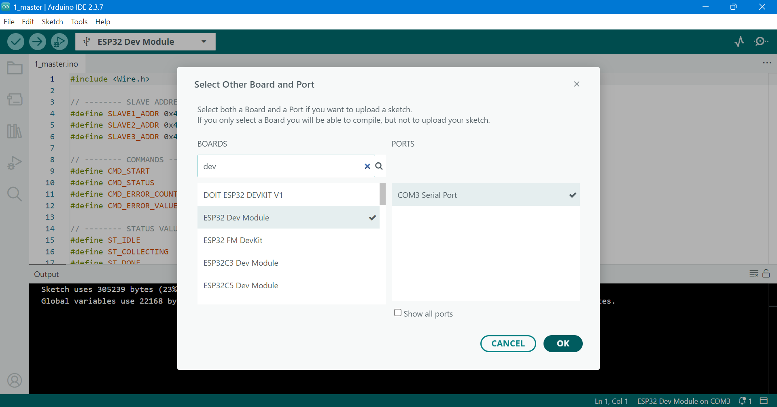
3. Export the compiled binary using: Sketch → Export Compiled Binary
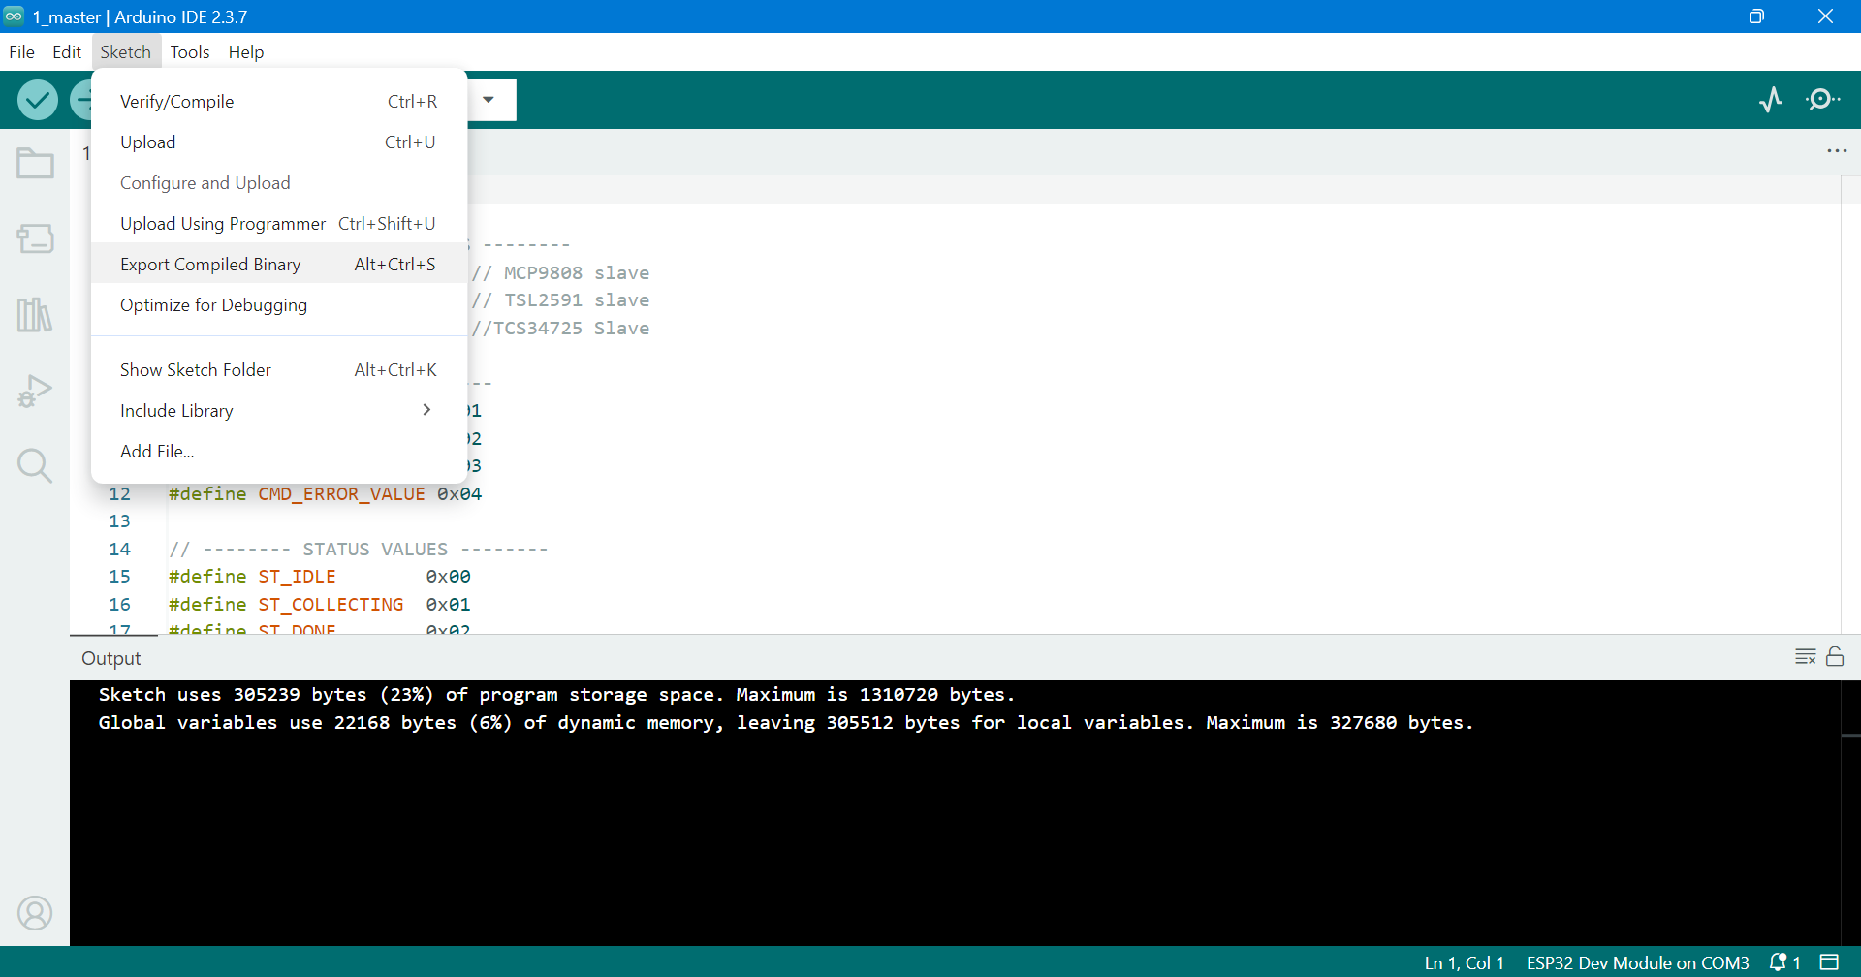
4. A .bin firmware file is generated
Step 5: Firmware Upload
- Upload the compiled firmware file: “.bin “ file.
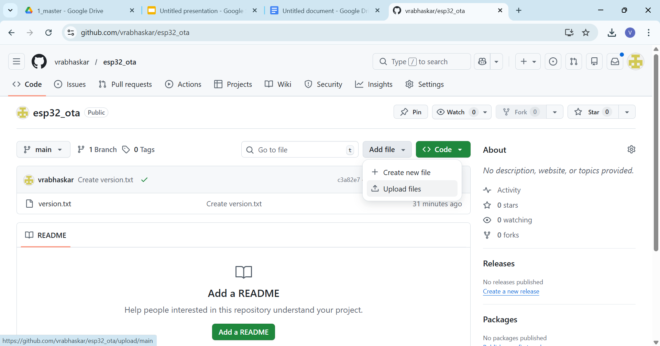
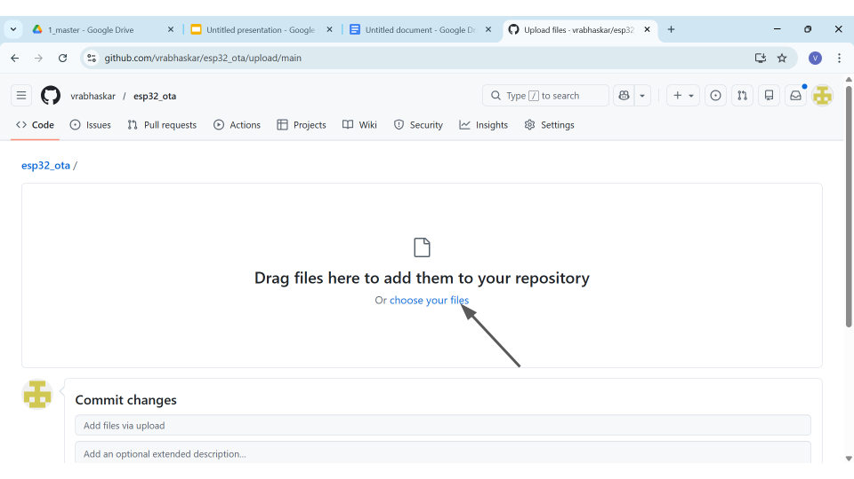
- Commit the changes to the repository.
- Rename filename.ino.bin to firmware.bin
- Click on filename.ino.bin file
- Click on Edit this file option.
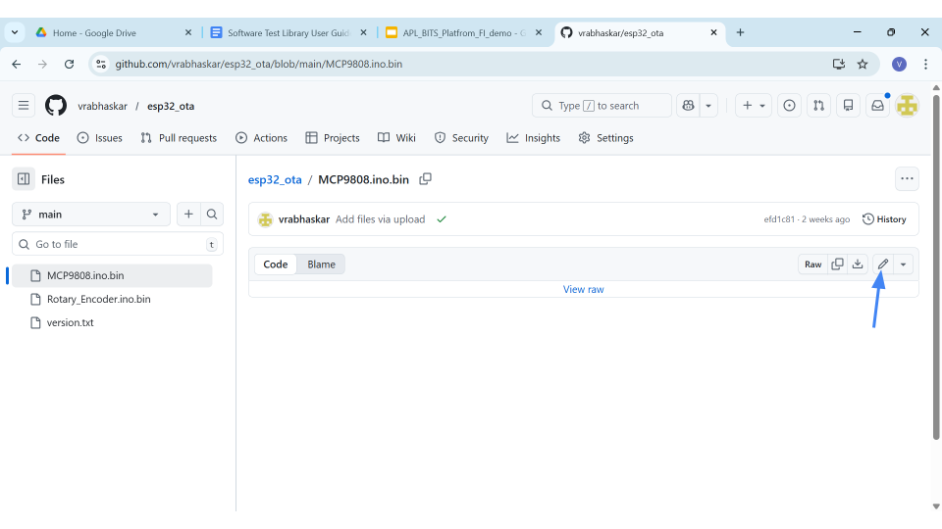
- Change the file name to firmware.in and click on Commit changes.
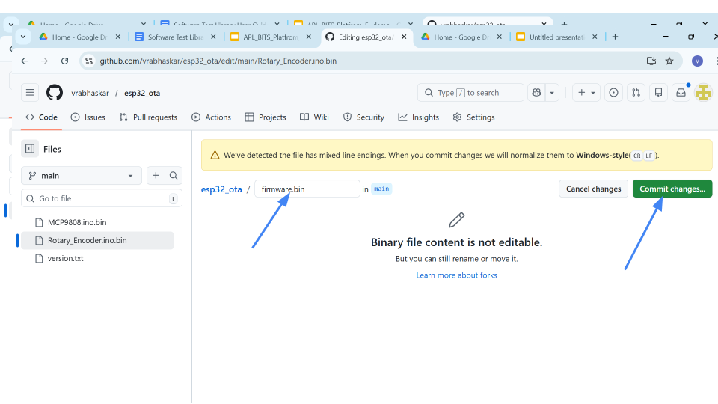

Step 6: Web Hosting Enablement
1. Open repository settings
2. Click Pages
3. Under Build and Deployment, set:
- Source: Deploy from a branch
- Branch: main
- Folder: /(root)
- Click Save
Wait for 1–2 minutes
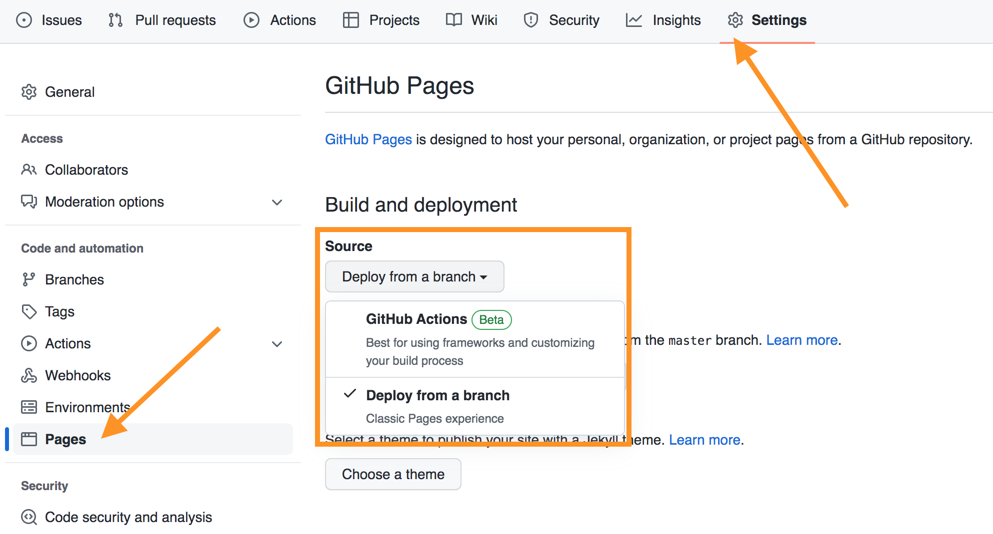
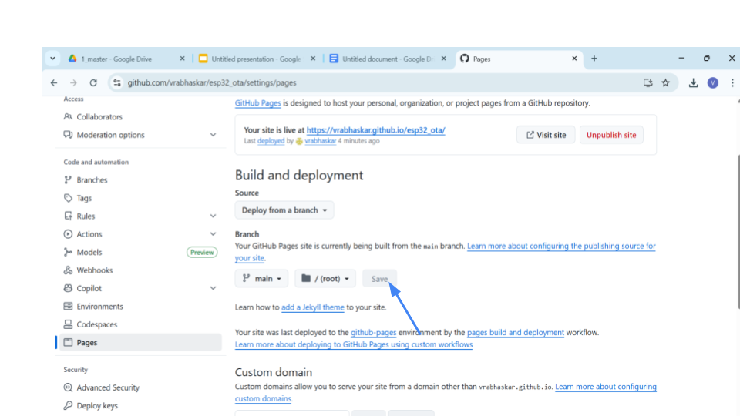
GitHub automatically creates a public website for hosting firmware files.

14.4 Initial Firmware Installation Requirement
The OTA update mechanism requires that the ESP32 be programmed once using a USB connection.
This initial firmware installation includes:
- Wi-Fi connectivity logic
- OTA update functionality
- Predefined URLs for version and firmware files
This step is performed only once. Afterward, the ESP32 can operate independently and perform firmware updates wirelessly.

14.5 Online Firmware Resources
Once hosting is enabled, the following resources become available:
- Version File:https://<username>.github.io/esp32_ota/version.txt
- Firmware File:https://<username>.github.io/esp32_ota/firmware.bin
Note: Replace <username> with the actual GitHub user ID.
The ESP32 accesses these resources during the update process.

14.6 Firmware Update Execution Flow
The firmware update process follows a defined sequence:
1. ESP32 connects to the configured Wi-Fi network
2. The online version file is read
3. Firmware version comparison is performed
4. If a newer version is available:
- Firmware is downloaded
- Flash memory is updated
- The system restarts with the updated firmware

